close all
% Read individual CSV files
dataRand = csvread('coverageRand.csv');
dataLevy = csvread('coverageLevy.csv');
dataFBE = csvread('coverageFBE.csv');
dataFixedRand = csvread('coverageFixedRand.csv');
dataFixedLevy = csvread('coverageFixedLevy.csv');
dataFixedFBE = csvread('coverageFixedFBE.csv');
dataFixedSBA = csvread('coverageFixedSBA.csv');
cMap = interp1(linspace(0, 1, 3), [1 0 0; 1 1 0; 0 1 0], linspace(0, 1, 256));
% Concatenate along the third dimension to create a 3D array
dataRMAP = cat(3, dataRand, dataLevy, dataFBE);
titleRMAP = {'Random Map Random', 'Random Map Levy', 'Random Map MMAFBE'};
dataFMAP = cat(3, dataFixedRand, dataFixedLevy, dataFixedFBE,dataFixedSBA);
titleFMAP = {'Fixed Map Random', 'Fixed Map Levy', 'Fixed Map MMAFBE','Fixed Map SBA'};
% Plot heatmaps for dataRMAP
for i = 1:size(dataRMAP, 3)
figure(i);
heatmap(dataRMAP(:,:,i), 'Colormap', turbo, 'ColorbarVisible', 'on');
caxis([0, 120]);
xlabel('X-axis');
ylabel('Y-axis');
title(titleRMAP{i});
end
% Plot heatmaps for dataFMAP
for i = 1:size(dataFMAP, 3)
figure(i + size(dataRMAP, 3)); % Use unique figure numbers
heatmap(dataFMAP(:,:,i), 'Colormap', turbo, 'ColorbarVisible', 'on');
caxis([0, 120]);
xlabel('X-axis');
ylabel('Y-axis');
annotation(gcf,'rectangle',...
[0.128906249999999 0.667735042735042 0.0627604166666657 0.0512820512820512],...
'LineWidth',0.01,...
'FaceColor',[0.650980392156863 0.650980392156863 0.650980392156863]);
annotation(gcf,'rectangle',...
[0.130208333333333 0.260683760683761 0.316145833333333 0.0544871794871795],...
'Color',[0.650980392156863 0.650980392156863 0.650980392156863],...
'FaceColor',[0.650980392156863 0.650980392156863 0.650980392156863]);
annotation(gcf,'rectangle',...
[0.319010416666665 0.669871794871795 0.0630208333333332 0.255341880341879],...
'Color',[0.650980392156863 0.650980392156863 0.650980392156863],...
'FaceColor',[0.650980392156863 0.650980392156863 0.650980392156863]);
annotation(gcf,'rectangle',...
[0.319010416666665 0.669871794871795 0.0630208333333332 0.255341880341879],...
'Color',[0.650980392156863 0.650980392156863 0.650980392156863],...
'FaceColor',[0.650980392156863 0.650980392156863 0.650980392156863]);
annotation(gcf,'rectangle',...
[0.633854166666665 0.719017094017094 0.0630208333333334 0.204594017094016],...
'Color',[0.650980392156863 0.650980392156863 0.650980392156863],...
'FaceColor',[0.650980392156863 0.650980392156863 0.650980392156863]);
annotation(gcf,'rectangle',...
[0.695833333333333 0.311965811965812 0.0630208333333334 0.306623931623932],...
'Color',[0.650980392156863 0.650980392156863 0.650980392156863],...
'FaceColor',[0.650980392156863 0.650980392156863 0.650980392156863]);
annotation(gcf,'rectangle',...
[0.821354166666666 0.719551282051282 0.0627604166666659 0.0512820512820511],...
'LineWidth',0.01,...
'FaceColor',[0.650980392156863 0.650980392156863 0.650980392156863]);
annotation(gcf,'rectangle',...
[0.758333333333333 0.567307692307692 0.1265625 0.0512820512820513],...
'Color',[0.650980392156863 0.650980392156863 0.650980392156863],...
'LineWidth',0.01,...
'FaceColor',[0.650980392156863 0.650980392156863 0.650980392156863]);
annotation(gcf,'rectangle',...
[0.445270833333333 0.261752136752137 0.0625416666666666 0.357905982905983],...
'Color',[0.650980392156863 0.650980392156863 0.650980392156863],...
'LineStyle','none',...
'FaceColor',[0.650980392156863 0.650980392156863 0.650980392156863]);
title(titleFMAP{i});
end
% Make all figures default fullscreen
hFigures = findobj('Type', 'figure');
for i = 1:numel(hFigures)
set(hFigures(i), 'Units', 'normalized', 'OuterPosition', [0, 0, 1, 1]);
end
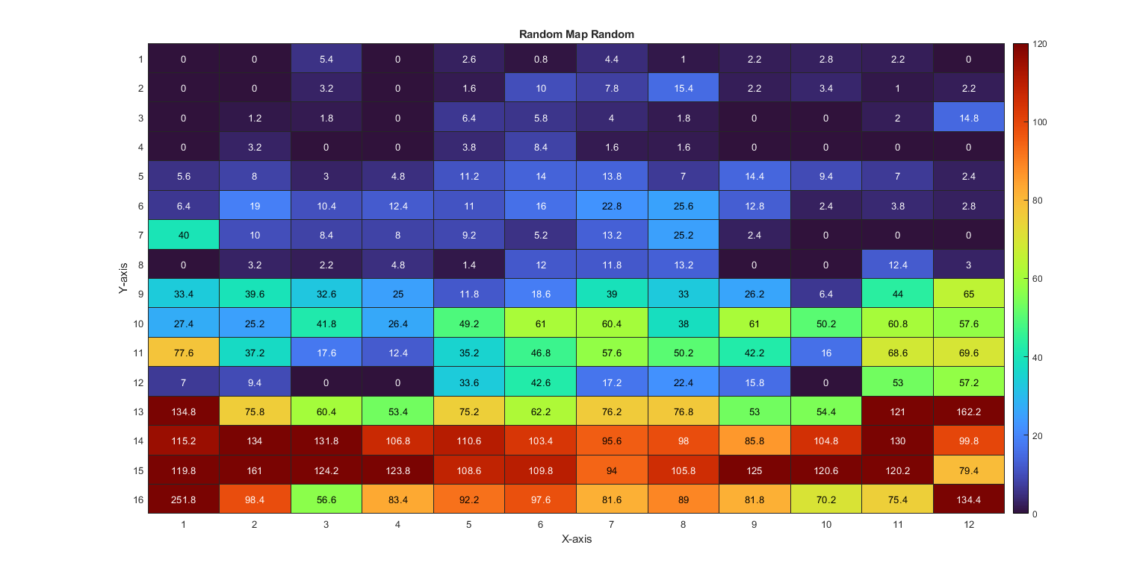
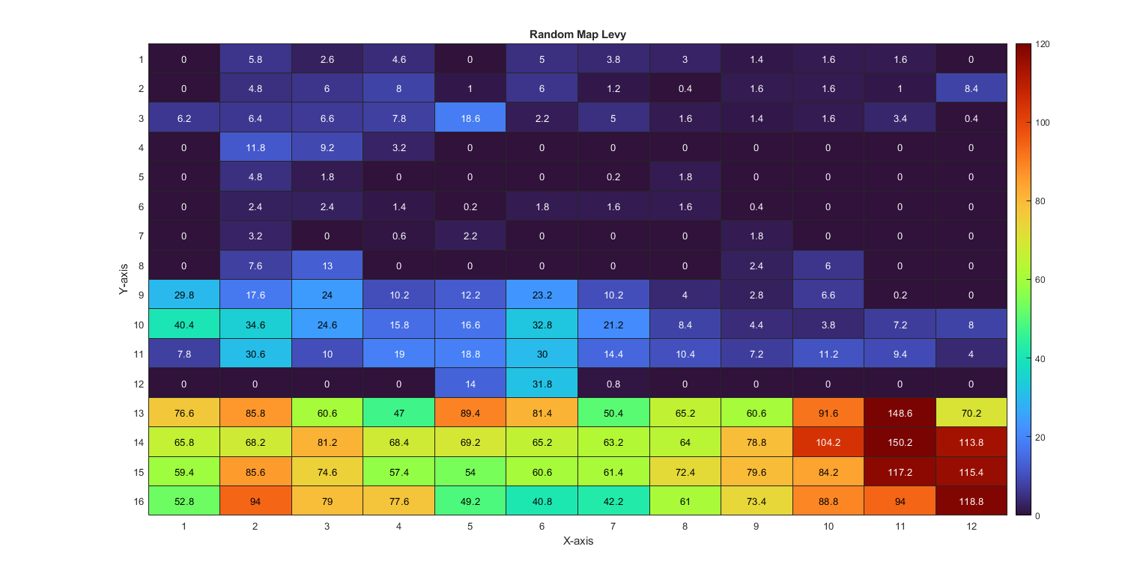
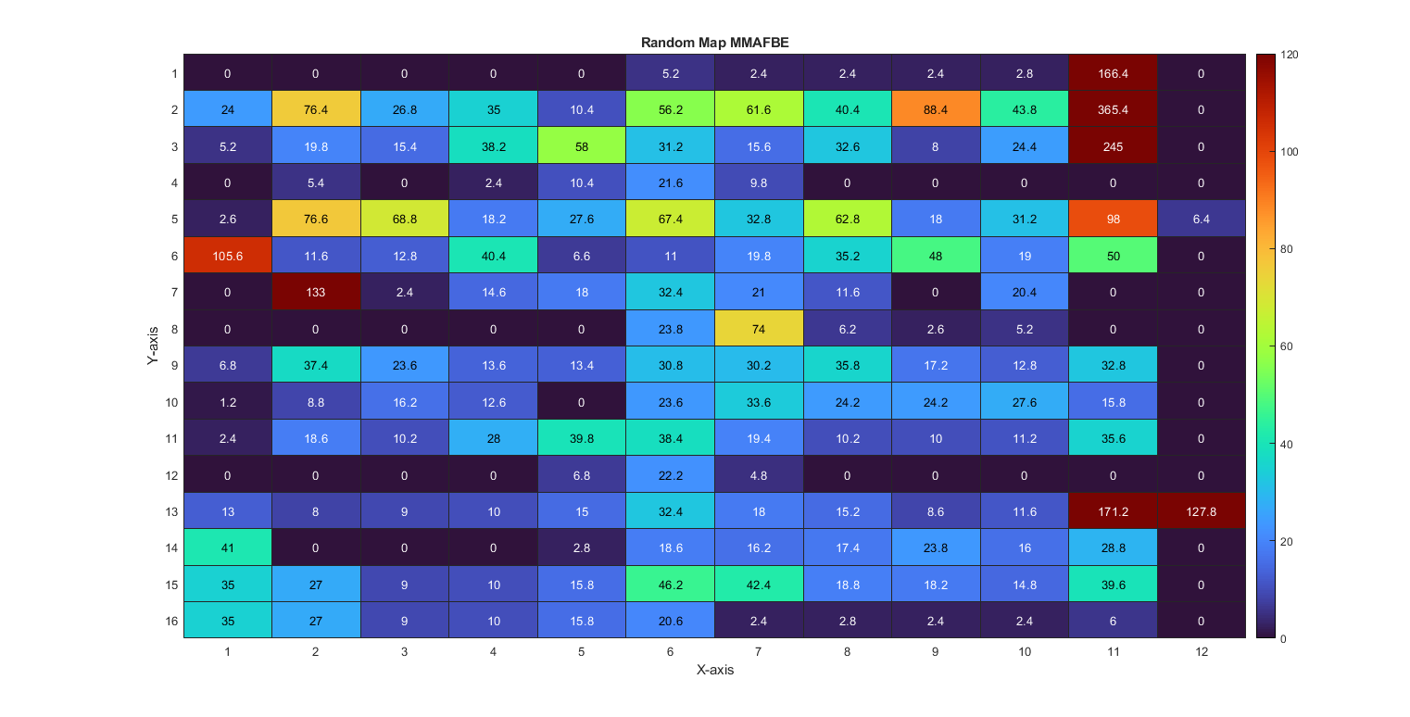
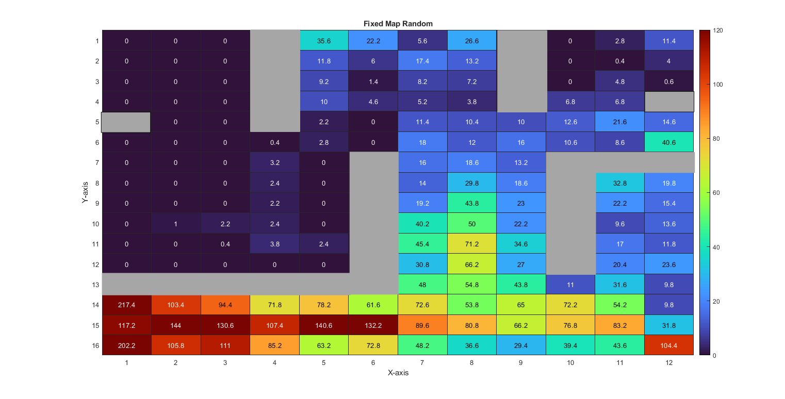
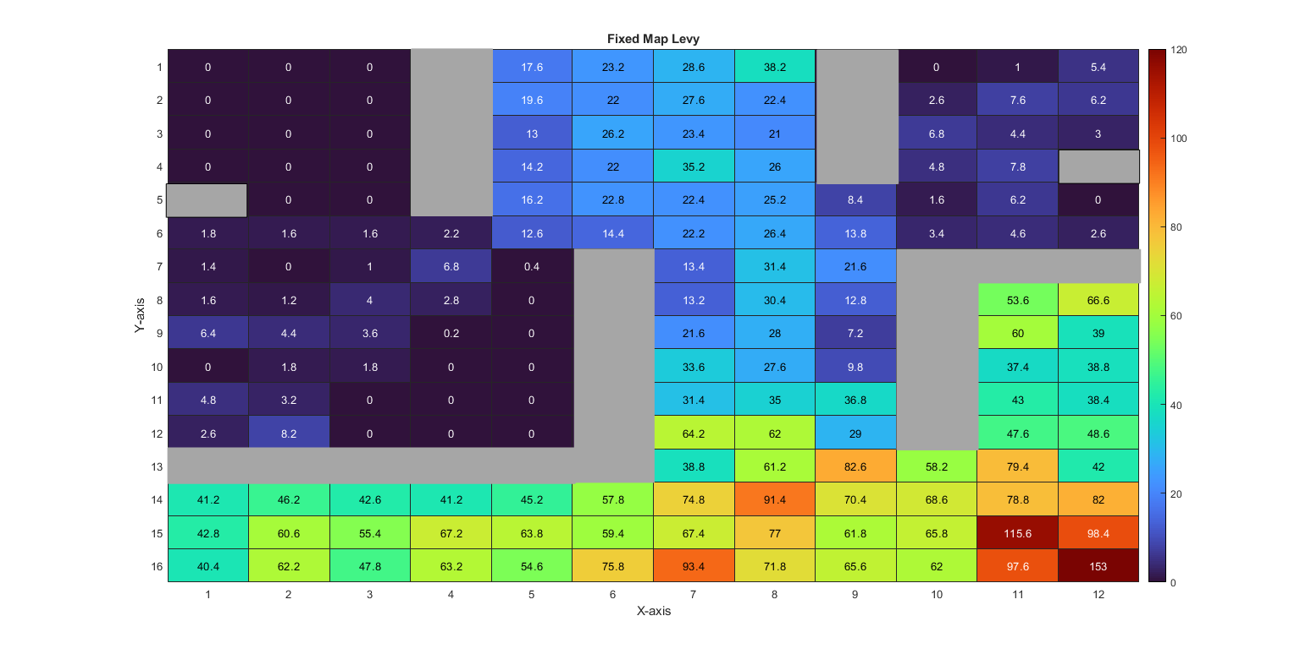
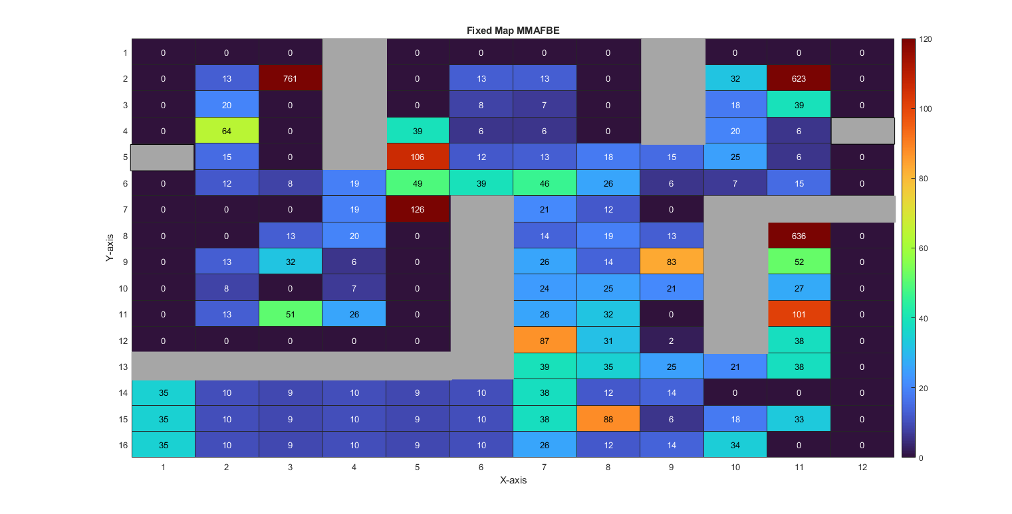
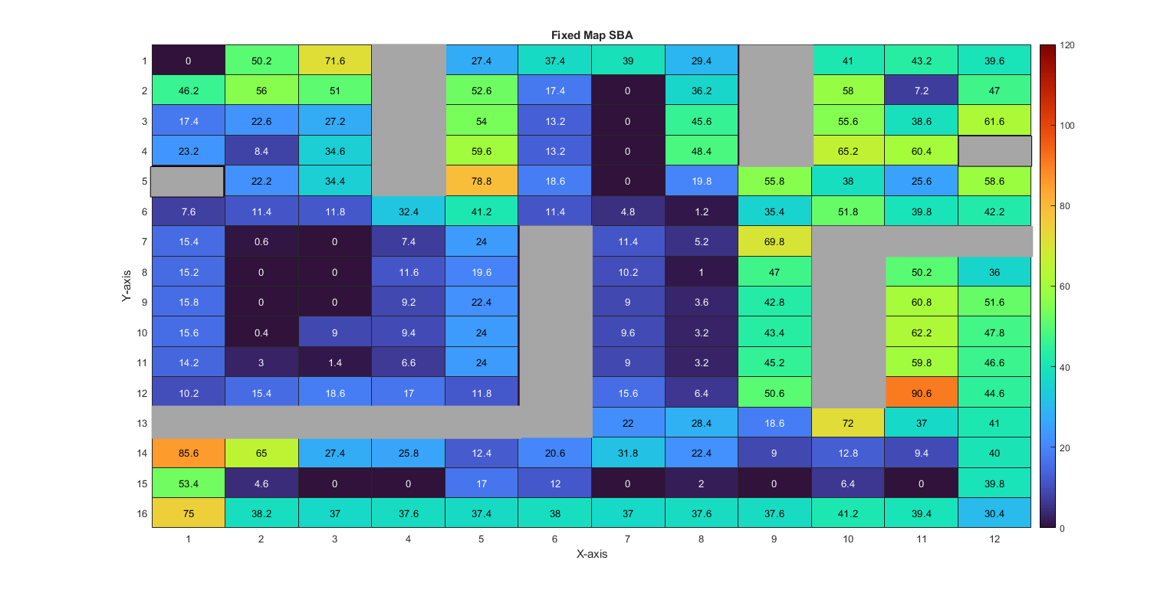
Published with MATLAB® R2020b

